Prophecy of the Red Horse of War
and the Blood Moons



One week from today, On January 31, 2018 on the Biblical Calendar of Shevat 15, 5778 will be a Super Blue Moon which will be also a Lunar Eclipse known as a Blood Moon
On January 21, 2019 on the Biblical Calendar of Shevat 15, 5779 will be another Blood Moon.

What is so Significant on the Biblical Calendar of Shevat 15. It’s Called Tu B’Shevat. It’s the vision given to the Prophet Zechariah in Zechariah 1:7-10 of the Red Horse of War in the month of Shevat. John mentions in Revelation 6:4 of the Red Horse of War.

The nations around the world are raging and are preparing for war and many people are not awake to see this coming! This is the time to get right with God and Receive Jesus as Lord and Savior.

Zechariah 1:7-10
7 On the twenty-fourth day, in the eleventh month, which is the month Shebat, during the second year of Darius, the word of the Lord came to the prophet Zechariah, son of Berekiah, son of Iddo: 8 I saw during the night a man riding on a red horse. But he was standing among the myrtle trees that were in the ravine, and behind him were red, sorrel, and white horses.

9 And I said, “What are these, my lord?” Then the angel who was speaking with me said, “I will show you what these are.” 10 Then the man who was standing among the myrtle trees responded and said, “These are the ones whom the Lord has sent out to walk to and fro on the earth.”

Revelation 6:3-4
3 When He opened the second seal, I heard the second living creature saying, "Come and see." 4 Another horse, fiery red, went out. And it was granted to the one who sat on it to take peace from the earth, and that people should kill one another; and there was given to him a great sword.

Wikipedia
Shevat in Jewish history and tradition
"The second year of Darius": 517 B.C.; 24 Shevat (517 BC) - Zechariah's prophecy (Zechariah 1:7-16)

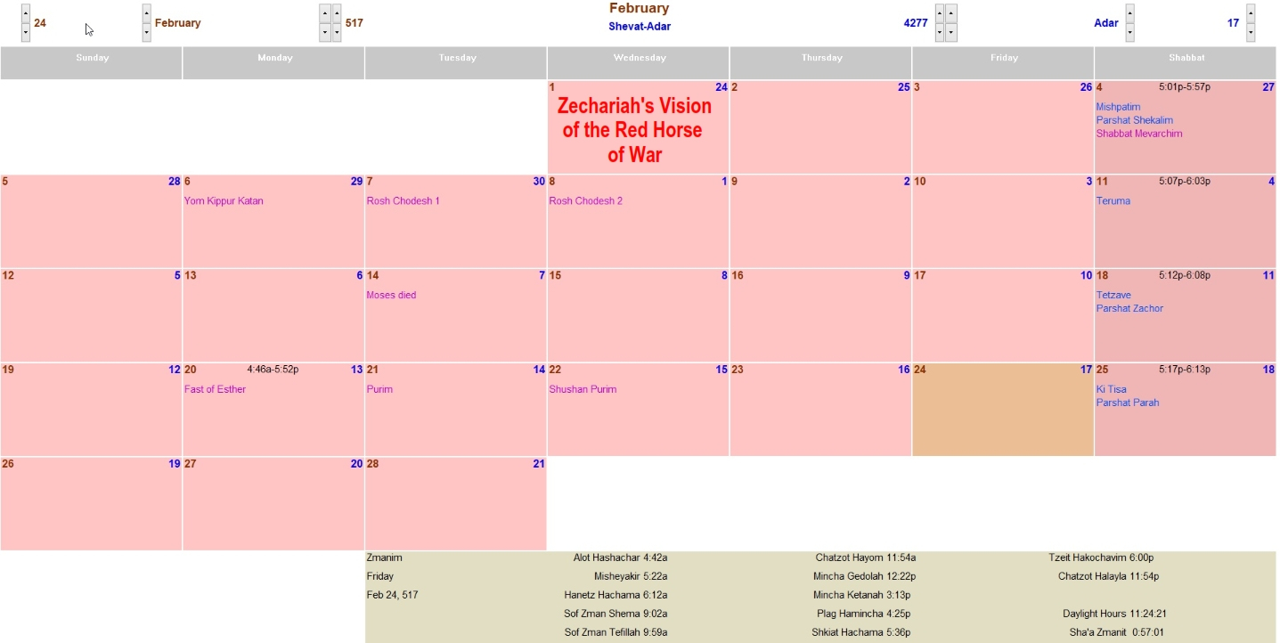

Photo of Biblical Calendar> 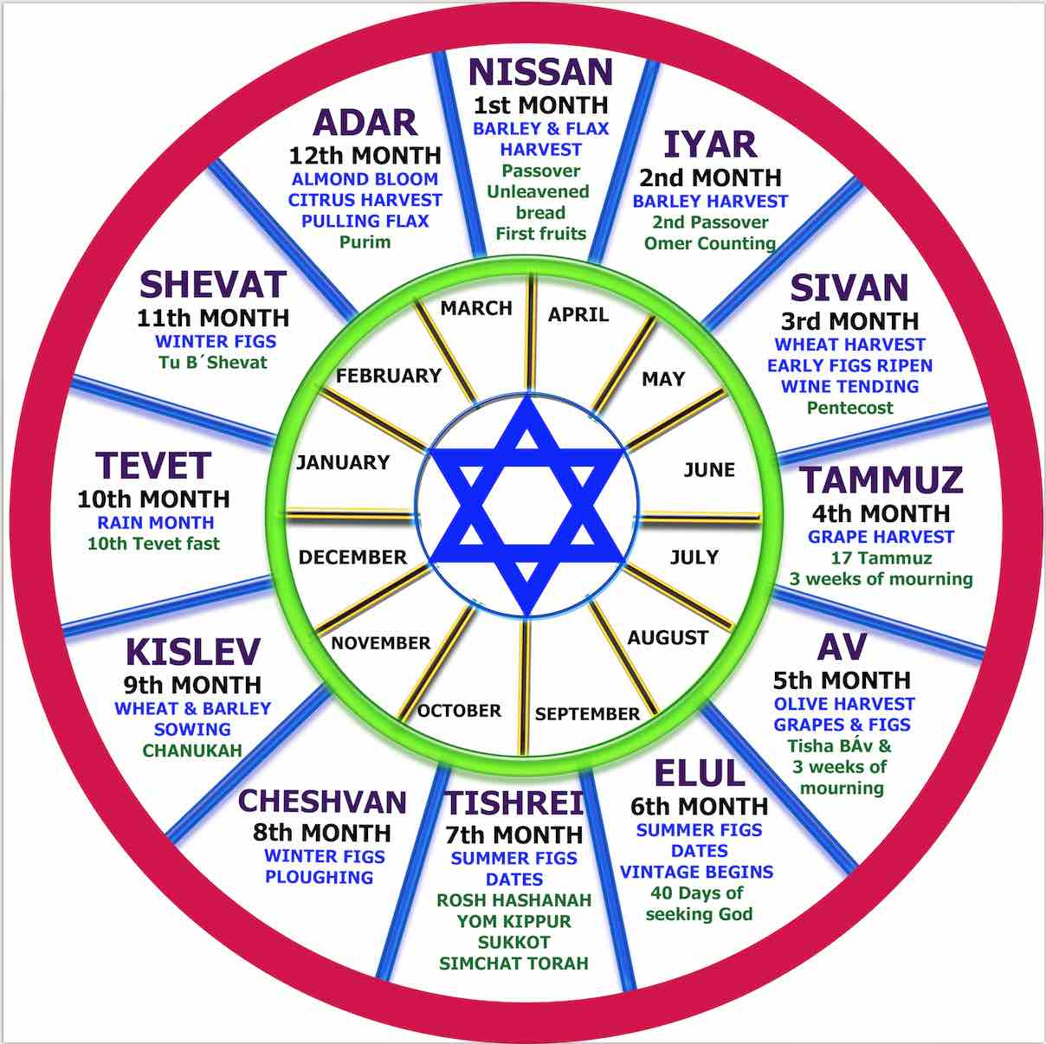

Pastor Mark Biltz Say’s
“These are very significant biblical dates, and now we have two blood red moons bookending each other in 2018 and 2019 on Tu B’Shevat,” he said. “This is fascinating prophetically because there is a section of Scripture in which Zechariah receives a revelation of a red horse being given a great sword to take peace from the Earth. And this takes place in the month of Shevat!” The relevant section of the Bible, Zechariah 1: 7-8, reads:

Upon the four and twentieth day of the eleventh month, which is the month Sebat, in the second year of Darius, came the word of the Lord unto Zechariah, the son of Berechiah, the son of Iddo the prophet, saying,

Upon the four and twentieth day of the eleventh month, which is the month Sebat, in the second year of Darius, came the word of the Lord unto Zechariah, the son of Berechiah, the son of Iddo the prophet, saying,

“Not surprisingly, Zechariah asks what this is all about, and he receives some incredible insight from an angel who is nearby,” Biltz explained. In verse 12, we are told, “Then the angel of the Lord answered and said, O Lord of hosts, how long wilt thou not have mercy on Jerusalem and on the cities of Judah, against which thou hast had indignation these threescore and ten years?”

Biltz argues this message is of key importance for people alive today. “Do you see the amazing pattern?” he asked. “The vision of the horses are of the four horses from Revelation. And this vision takes place at the end of a 70-year period (three score and ten) which is given to Israel. Israel is now celebrating its seventieth anniversary.”

He also argues the mention of the “second year of Darius” is also of critical importance, as the second year of President Trump’s administration approaches. As head of the world’s most powerful nation, Trump can substitute for Darius in contemporary prophetic terms.

“What this suggests is the red horse of war being unleashed very soon, and these moons heralding its arrival,” he said. “Again, I’m not predicting anything will happen on the day of the moon itself. Instead, I would look for war to break out between the two blood moons which take place a year apart on Tu B’Shevat. More than ever, it’s important for Christians to get on God’s calendar, the biblical calendar, and learn to interpret the signs of the times.

It’s not just about what is happening in the sky, it is about when it is happening. And the correlation between this ‘super blue blood moon’ and historic events in the Middle East lining up with specific dates listed in Scripture should make all believers to get right with the Lord as soon as they can.”

